Past Exam Questions
Section – 3.5

- Which one of the following functions does not have a horizontal asymptote?

- The graph of the function has:
- Only one vertical asymptote given by
- Only one vertical asymptote given by
- Two vertical asymptotes given by and
- A slant asymptote given by
- Three x-intercepts

- If is a horizontal asymptote for the graph of then the vertical asymptote(s) will be
- and
- and

- The equation of the slant asymptote for is

- Which one of the following functions has the graph given below?
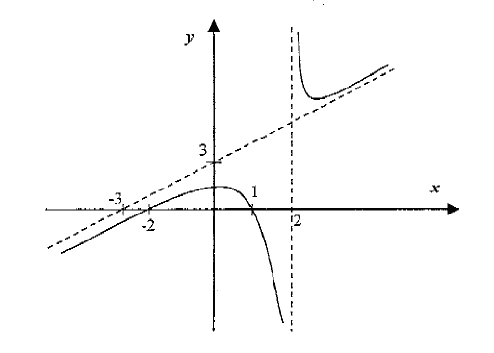

- If the graph of has the line as a vertical asymptote, then it has a horizontal asymptote given by

- (b) (c) (d) (e)

- Which one of the following functions has the graph given below?
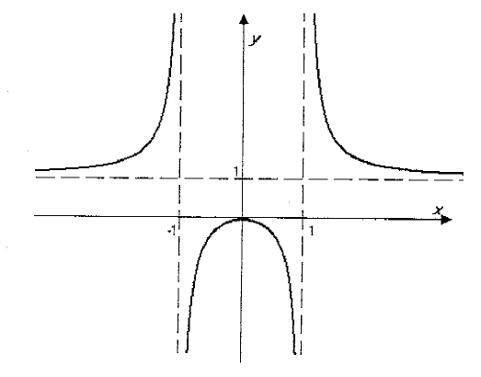

- The graph of intersects its horizontal asymptote when x is equal to:

- An equation of the slant asymptote of the graph of is
- The graph of the rational function is
- Increasing for every x in its domain
- Decreasing for every x in its domain
- Decreasing on and increasing on
- Decreasing on and increasing on
- Decreasing on and increasing on

- The asymptotes of the graph of the function are:
- One vertical and one horizontal
- Two vertical and one horizontal
- One vertical, one slant and one horizontal
- Two vertical and one slant
- Two vertical and neither horizontal nor slant

- The graph of the rational function lies completely above its slant asymptote on the interval

- The Equations of the vertical asymptote and the slant asymptote of the graph of are respectively
- and
- and
- and
- and
- and

- The graph of the function is decreasing on the interval D and has an open circle at (a, b) where [Hint: sketch]

