Check Your Attendance Online !!!
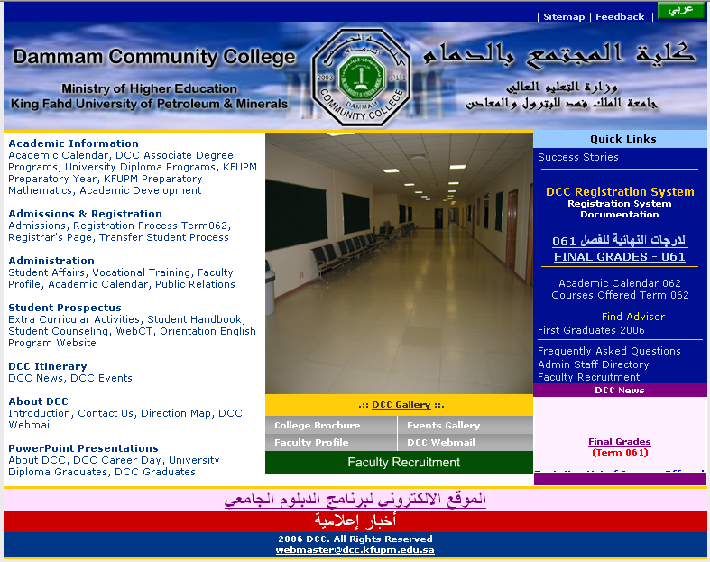

STEP
1
To Login click
DCC Registration System
If you are using the Registration System for the first time, it is recommended that you change your password.

STEP
2

STEP
3

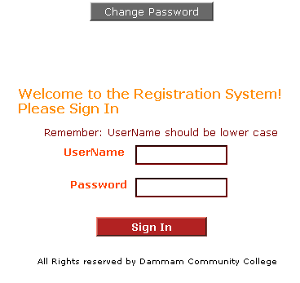  1 – Enter Username  2 – Enter Password  Your username and password is the same as your Student ID  Student ID  Student ID | 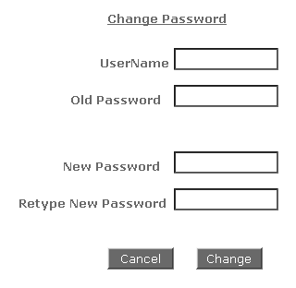  Enter your New password here and retype it below to confirm the password. Then Click the Change button to change the password.  Change Password  Enter your Username in UserName text area and your password in the Old Password text area.

Changing and maintaining the password is student’s responsibility

